MILESTONE 2

1. Milestone Overview
Milestone 2 is titled “Creation Of importset Table And Transform Map”. It explains how the spreadsheet data is first stored in an Import Set Table and then mapped to the target Employee Test table through a Transform Map.
Milestone Detail | Value
Milestone | Milestone 2: Creation Of importset Table And Transform Map
Project | Import Data using Transform Maps (Spreadsheet)
Complexity | Medium
Duration | 40 minutes
Main Activities | Creation of Import Set Table; Creation of Transform Map

2. Description
The Import Set Table is a temporary staging table used to store employee data uploaded from the spreadsheet. It contains fields such as Employee ID, Name, Email, Department, and Location. The imported data is stored in this table before it is validated and transformed into the final employee records.
The Transform Map defines how data from the Import Set Table should be transferred to the target Employee Test table. It maps fields such as Employee ID, Name, Email, Department, and Location from the imported data to the corresponding target fields. Employee ID can be used as the coalesce field to update an existing employee record or create a new record when the employee does not already exist.

3. Story 1 – Creation of Import Set Table

3.1 Purpose
The Import Set Table provides the temporary staging area for the spreadsheet records. The uploaded spreadsheet data is stored here before the Transform Map moves the data into the Employee Test target table.

3.2 Navigation
ServiceNow → Application Navigator → Load Data

3.3 Procedure
1. Go to the Application Navigator in ServiceNow.
2. Open or search for Load Data.
3. Click Load Data and start the process for creating an Import Set Table.
4. Fill in the Import Set Table details.
5. Set the Label to: Employee Import.
6. The Name is auto-populated as: u_employee_import.
7. Submit the Import Set Table creation.
8. After submission, use the Create Transform Map option to continue to the next activity.

3.4 Import Set Table Details
Property | Value
Label | Employee Import
Name | u_employee_import
Purpose | Temporary staging of spreadsheet employee data
Source | Spreadsheet / Excel data prepared in Milestone 1

3.5 Import Set Fields
Field | Imported Information
Employee ID | Employee data from the uploaded spreadsheet
Name | Employee data from the uploaded spreadsheet
Email | Employee data from the uploaded spreadsheet
Department | Employee data from the uploaded spreadsheet
Location | Employee data from the uploaded spreadsheet

3.6 Screenshot – Import Set Table
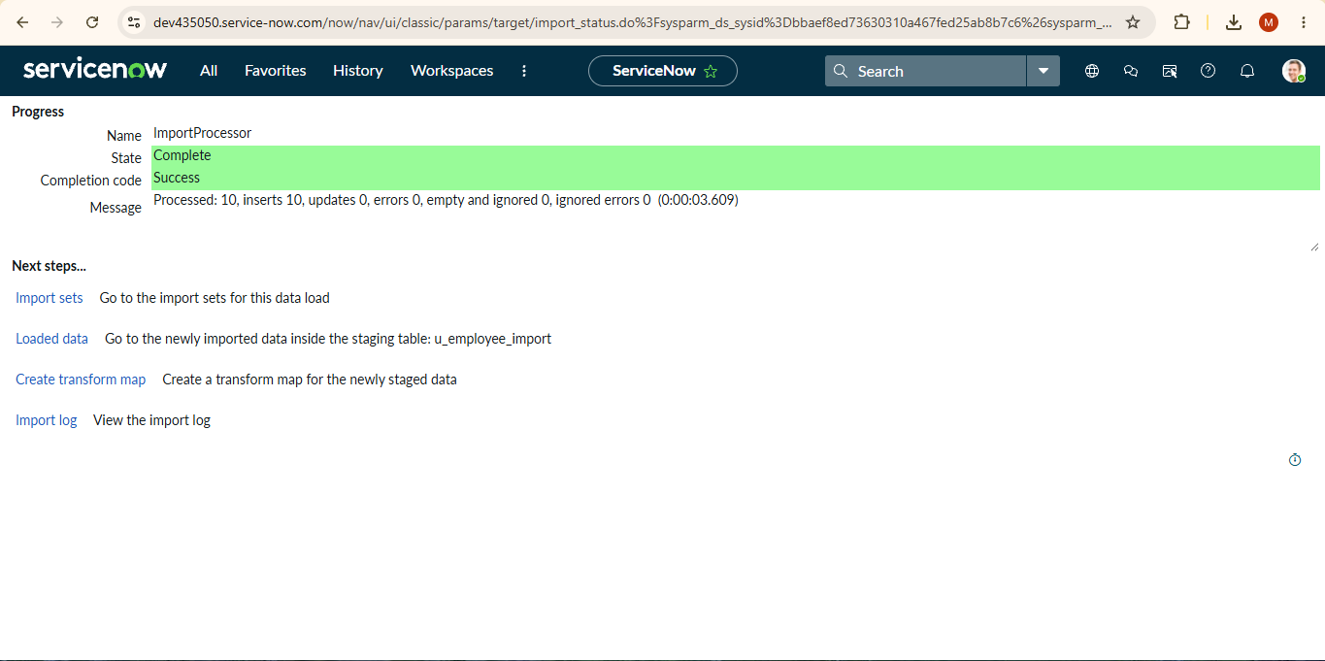
Figure 1: Import Set Table creation and Load Data configuration

4. Story 2 – Creation of Transform Map

4.1 Purpose
The Transform Map defines the relationship between the source fields in the Employee Import staging table and the corresponding fields in the Employee Test target table. This mapping controls how the imported spreadsheet records are transferred into the target table.

4.2 Transform Map Details
Property | Value
Transform Map Name | Sample Spreadsheet Import
Source Table | Employee Import
Target Table | Employee Test
Source Table Name | u_employee_import
Target Table Name | u_employee_test

4.3 Procedure
1. Open the Transform Map creation page.
2. Enter the Transform Map name as: Sample Spreadsheet Import.
3. Select Employee Import as the Source Table.
4. Select Employee Test as the Target Table created in Milestone 1.
5. Click Auto Map Matching fields so that matching source and target fields are mapped.
6. Save the Transform Map.
7. Verify that the required Source and Target table fields are mapped correctly.
8. Click Transform to execute the transformation of the imported data.
9. Open the Transform link/result area and verify the transformation details.
10. After the transformation is completed, verify the success message shown by ServiceNow.

4.4 Field Mapping
Source Field | Target Field | Purpose
Employee ID | Employee ID | Transfers the corresponding employee value to the target table.
Name | Name | Transfers the corresponding employee value to the target table.
Email | Email | Transfers the corresponding employee value to the target table.
Department | Department | Transfers the corresponding employee value to the target table.
Location | Location | Transfers the corresponding employee value to the target table.

4.5 Coalesce Field Reference
The milestone description specifies that Employee ID can be used as the coalesce field. When enabled in the Transform Map workflow, Employee ID can identify an existing employee record for updating, while a record with a new Employee ID can be inserted as a new employee record. The detailed duplicate-prevention behavior is handled in the next milestone.

4.6 Screenshots – Transform Map
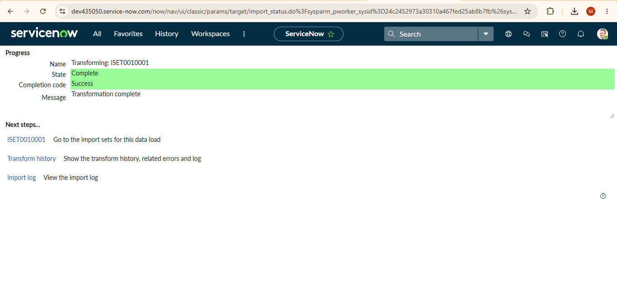
Figure 2: Transform Map configuration, field mapping, and transformation

5. Milestone 2 Workflow
Spreadsheet Data → Employee Import (Import Set Table) → Sample Spreadsheet Import (Transform Map) → Employee Test (Target Table)

6. Expected Result
After completing Milestone 2, the spreadsheet data is available in the Employee Import staging table and a Transform Map named Sample Spreadsheet Import connects the source table to the Employee Test target table. The required employee fields are mapped and the transform operation can be executed to move the imported data into the target table.

7. Completion Checklist
☐ Employee Import Import Set Table created.
☐ Import Set Table name set to u_employee_import.
☐ Employee ID, Name, Email, Department, and Location fields available for imported data.
☐ Transform Map named Sample Spreadsheet Import created.
☐ Source Table selected as Employee Import.
☐ Target Table selected as Employee Test.
☐ Auto Map Matching fields applied.
☐ Source and Target fields checked for correct mapping.
☐ Transform operation executed.
☐ Transformation success message verified.

8. Conclusion
Milestone 2 establishes the Import Set and Transform Map required for the spreadsheet import workflow. The Employee Import table temporarily holds the uploaded spreadsheet data, while the Sample Spreadsheet Import Transform Map defines how the data is transferred to the Employee Test table. This prepares the project for the next milestone, where the transformed data is validated and coalesce is used to avoid duplicate records.

9. Source Alignment
This report is structured according to the Milestone 2 instructions shown in the supplied SkillWallet screenshots and the supplied project material. It covers the two activities shown for this milestone: Import Set Table creation and Transform Map creation.

